**Hamburger Menu Implementation Process**

Firstly I implemented two “mobile-nav” divs. The first one to be used to style the hamburger menu and ensure it toggles the menu on click. The second div acts as the mobile navigation links which will be hidden on desktop but visible on mobile devices. This will be done using CSS.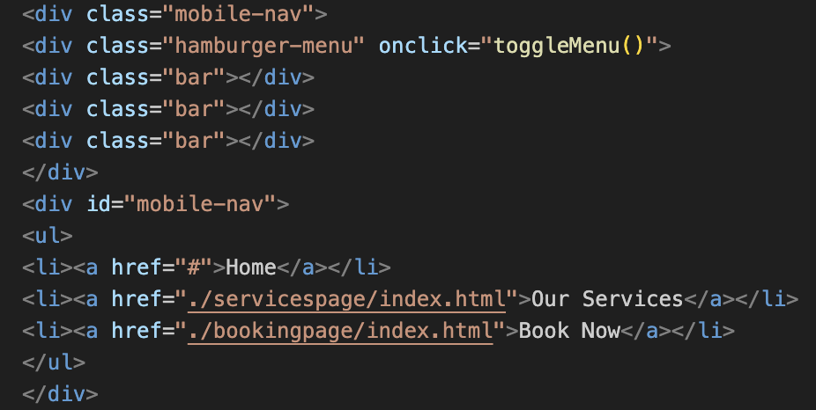

I then styled the hamburger menu in CSS. I used “.hamburger-menu.active” + “#mobile-nav.active” to make sure they displayed correctly when active.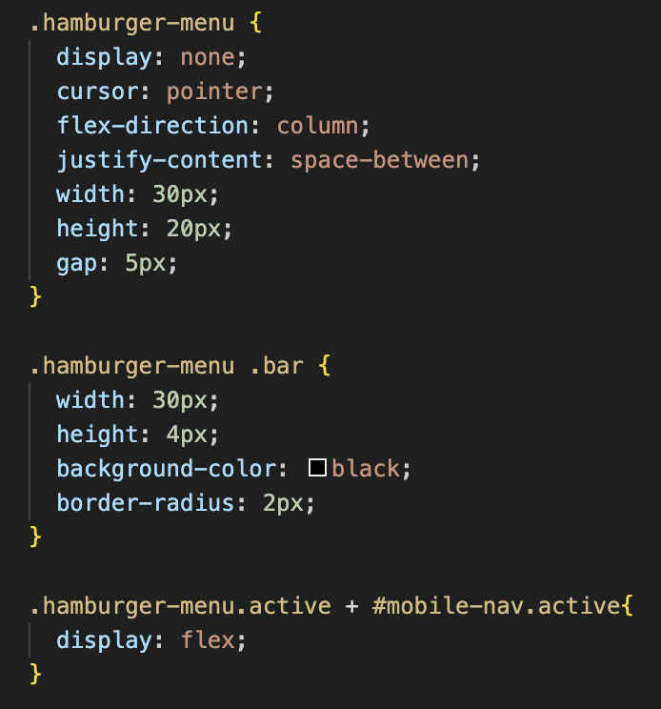

Finally, I added in the Javascript functionality. I began by creating the “toggleMenu” function. It retrieves the mobile-nav & .hamburger-menu elements from the html. By using “mobile.Nav.classList.toggle(‘active’)” & “mobile.Nav.classList.toggle(‘active’)” it toggles the hamburger menu a ‘active'.

document.querySelector(‘.hamburger-menu’).addEventListener(‘click’, toggleMenu); & document.querySelector(‘.hamburger-menu’).addEventListener(‘touchstart’, toggleMenu); toggle the hamburger menu when it is clicked. Touchstart ensures better event listening on mobile touch screen devices.

After adding the final code, I then further played with CSS styling for the menu.

